KUNAL JHINDAL (24070126098)-AIMLB1
ASSIGNMENT-3
Create a Book class with appropriate constructors.
Create a User defined exception class called InvalidPriceException.
One of the constructors of Book should throw InvalidPriceException if the price < 0.
Create another class called ArrayListOfBooks with main method.
Create multiple Book objects and add them to an ArrayList of Books.
Use the constructor that throws InvalidPriceException inside a try-catch block and try to create a Book object with negative price value.
The output should display the attribute values of all objects from the ArrayList. Also, calculate the average price of books and print it.
Also, print books of a particular genre such as "Fiction" using forEach() method of ArrayList.
Github-https://github.com/kjuhi-18/Java-Lab-Assignments/tree/main/Assignment%202
CODE:
book.java
public class book {
public String title;
public double price;
public String ISBN;
public String genre;
public String author;

public book(){
title = "Ready Player One";
price = 458;
ISBN = "ABR4212";
genre = "Fiction";
author = "Ernest Cline";
}

public book(String title, double price, String genre ) throws InvalidPriceException,InvalidGenreException
{
this.title = title;
if (price<0)
throw new InvalidPriceException("Price cannot be negative");
this.price = price;
if (!genre.equals("Fiction") && !genre.equals("Non-fiction") && !genre.equals("Auto-biography"))
throw new InvalidGenreException("Invalid genre");
this.genre = genre;
}

public book(String title, double price, String ISBN, String genre, String author) throws InvalidPriceException,InvalidGenreException
{
this.title = title;
if (price<0)
throw new InvalidPriceException("Price cannot be negative");
this.price = price;
this.ISBN = ISBN;
if (!genre.equals("Fiction") && !genre.equals("Non-fiction") && !genre.equals("Auto-biography"))
throw new InvalidGenreException("Invalid genre");
this.genre = genre;
this.author = author;
}

public book(book b){
this.title = b.title;
this.price = b.price;
this.ISBN = b.ISBN;
this.genre = b.genre;
this.author = b.author;
}

}
mainbook.java
import java.util.ArrayList;

public class mainbook {
public static void main(String[] args) {
ArrayList<book> alb = new ArrayList<book>();
try{
book b1 = new book("Icon", 499, "Fiction");
alb.add(b1);

book b2 = new book();
alb.add(b2);

book b3 = new book(b2);
b3.title = "Harry Potter";
b3.author="JK Rowling";
alb.add(b3);
book b4 = new book("Outlive", 370, "ABDK223", "Non-fiction", "Peter Attia");
alb.add(b4);
book b5 = new book("My experients with truth", 549, "ABCD3101", "Ficttuoyion", "Mahatama Gandhi");
alb.add(b5);
book b6 = new book("Mein Kampf", 999, "NA67ZI", "Auto-biography", "Adolf Hitler");

alb.add(b6);
}
catch(InvalidPriceException ip){
System.out.println(ip.getMessage());
}
catch(InvalidGenreException ip){
System.out.println(ip.getMessage());
}

int temp = 0;
int len = 0;
for(book b : alb){
if(b.genre.equals("Fiction")){
System.out.println("------------------");
System.out.println(b.title);
System.out.println(b.price);
System.out.println(b.author);
System.out.println(b.ISBN);
System.out.println(b.genre);
System.out.println("------------------");

len +=1;
}
}
System.out.println("Fiction books: " + len);
len = 0;
for(book b : alb){
len +=1;
temp += b.price;
}
System.out.println("Average price: " + temp/len);

}
}
InvalidGenreException.java
public class InvalidGenreException extends Exception {
public InvalidGenreException(String msg){
super(msg);
}

}
InvalidPriceException.java
public class InvalidPriceException extends Exception{
public InvalidPriceException(String m){
super(m);
}
}

OUTPUT:
Making Price Negative:
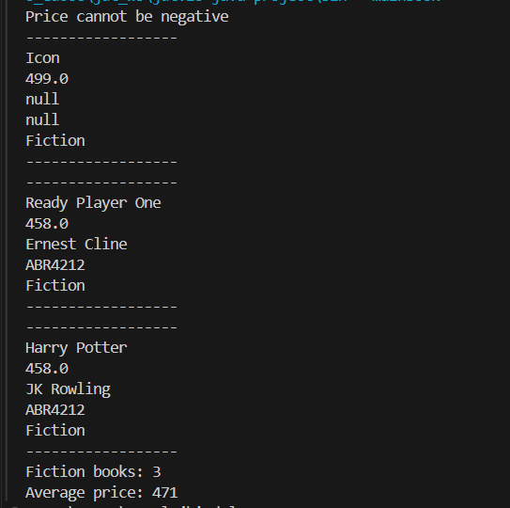

Invalid genre:

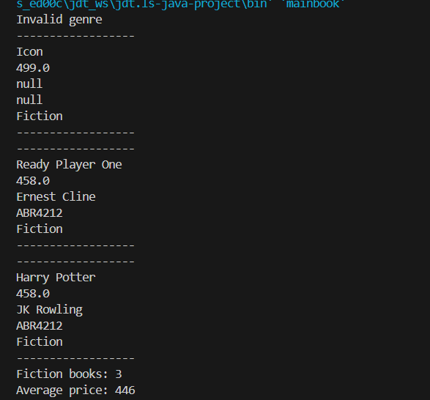
All the books of type”FICTION” with avhg price of all the books.
